AFFIDAVIT
I, PREETHI.V son / daughter of VARADHARAJAN K residing at East
Ellaiamman Kovil Street Kottur Chennai 600085 and my date of birth is 06/12/2004
and have joined in Sathyabama Institute of Science and Technology, Deemed to be
University and my Register Number is 250515 at Sathyabama Institute of Science and
Technology, Deemed to be University, Jeppiaar Nagar, Rajiv Gandhi Salai, Chennai
600119. hereby SIGN THIS Affidavit with clarity of information and presence of mind and
without any under influence or coercion. Any disputes relating to this affidavit comes under
Chennai Jurisdiction only.

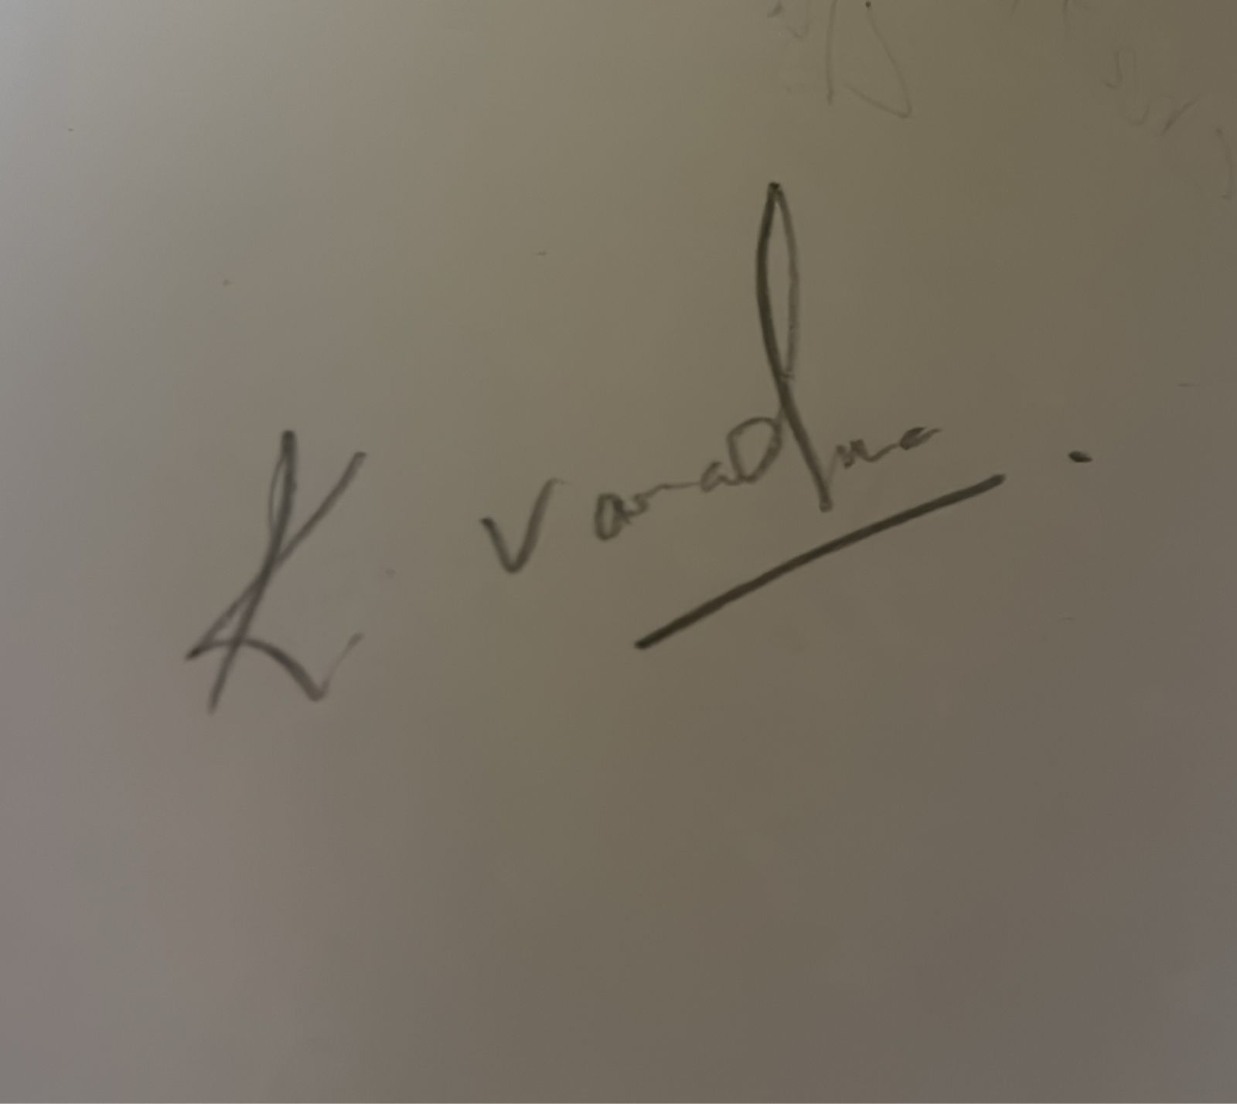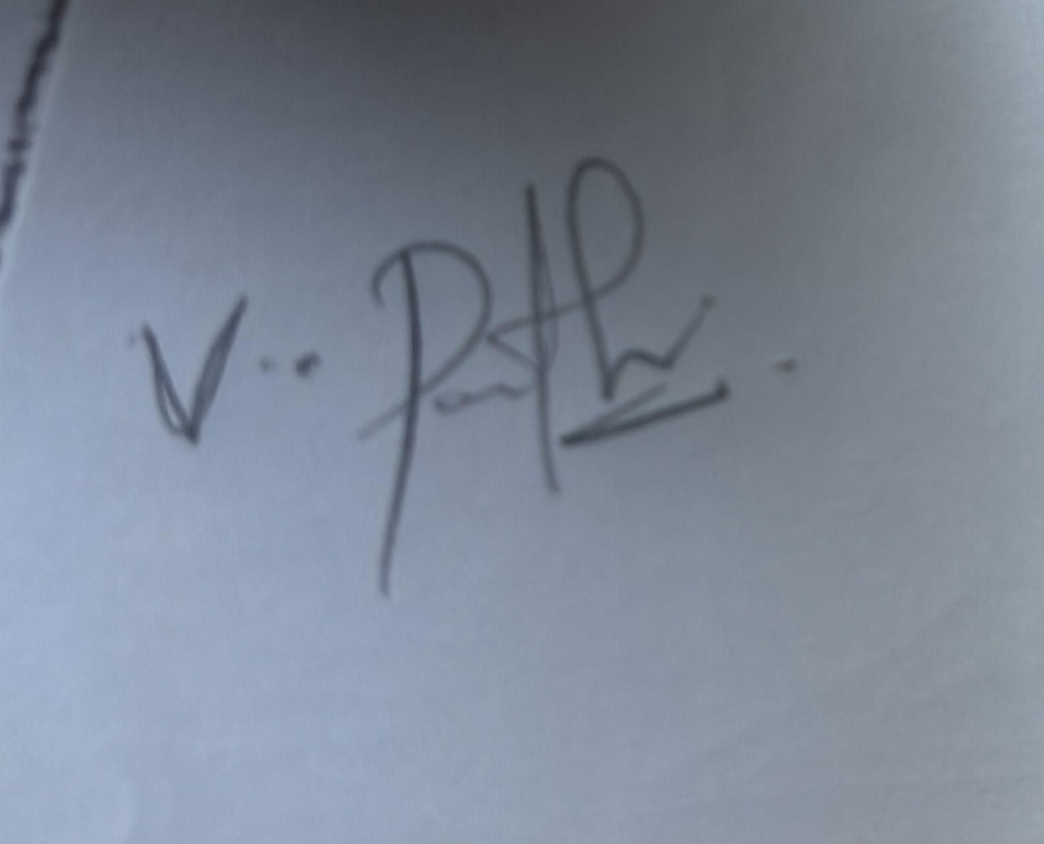

GENERAL RULES AND REGULATIONS:
- ERP: I am aware that I will be given an ERP login credentials which I will be using only for the academic purpose. No part of the information provided in the ERP is neither misleading nor wrong information. Further, I will update the ERP credentials whenever there is any change.
- LMS: I am aware that I will be given LMS credentials in order to submit my assignments, to participate in Quiz conducted by the Department. Am also aware that these evaluations are carried out in order calculate the internal marks as per the academic regulations.
- HOSTEL: I am aware that Hostel facility (if availed), is provided on the basis of separate payment made to avail Hostel facility. Further,
  - I will be residing in the same room as it is allocated by the Hostel Administration.
  - I will not involve in any In-disciplinary acts brings damage either to the Institution or to myself.
  - I will not cause any damage to any Hostel property. In all such events, if found guilty, I will bear the cost of the replacement of equipment.
  - I am aware that the Hostel fee payment is on yearly basis. There is no pro rate basis or monthly calculations are involved.
  - I am aware that if I vacate the Hostel either on disciplinary grounds or on my personal grounds, I will not claim either the refund of Hostel fee or adjustment of Hostel fee in all my future fee commitments to the Institution.
  - I am aware that I should not involve in celebration of any category, in any form inside the Hostel premises.
  - I am aware that I will not allow any stranger (not a Hostel inmate) to stay in my room.
  - Day scholars are not permitted to stay inside the Hostel under any circumstances.

  - Hostel inmates may avail Hostel outing as per the Hostel Regulations. Institution Management shall not be held responsible for any loss or property or any kind of mishap during the outing.
- CELEBRATIONS OF PERSONAL FUNCTIONS / MEETINGS: I am aware that I
should not organize any personal functions / participate in any personal functions / personal meetings or celebrate any festival within / outside the hostel. There should be not be any celebrations either inside the classroom or inside the hostel, particularly Birthday’s and any other special events
- DISCRIMINATION: As the Institution is resistance any discrimination in the form of caste, creed and gender, I will not involve any form of the activity that causes in disciplinary act.
- PROMOTION OF ANY ORGANIZATION: I am aware that Sathyabama does not encourage or support any organization or any Personality. Hence, I will not involve any kind of act that supports any political party or Personalities inside the campus, especially during culturals.
- UNIVERSITY TIMINGS: I am aware of the Institution timings and I will be abiding by the same. Further, I will not leave the campus within the working hours, without prior permission.
- TRANSPORTATION SYSTEM: I am aware that Transportation is provided by the Institution. I will not involve in any in-disciplinary act that causes damage to the fleet. Further, I will not cause any disturbance to my fellow students or staff inside the Buses.
- OWN TRANSPORTATION: I may utilize my own transportation to come to the campus. However, I need to park my vehicle in the parking space provided for the students. Management will not be held responsible for any loss or theft or damage to my personal vehicle.
- DRESS REGULATIONS: I am aware that I should come to the Institution Dress Code as prescribed by the Institution. Indecent dress in the form of torn clothes will not be permitted inside the Institution.

- ATTENDANCE AND AVAILING LEAVE: I am aware of the minimum attendance requirement as per Academic regulations and I will abide by the same throughout my course of study.
- ASSESSEMENT TESTS: I am aware of the continuous evaluation and assessment system as per Academic regulations and I will abide by the same throughout my course of study.
- MAL PRACTICE IN THE EXAMINATIONS: Malpractice includes maladministration and means any act, default or practice which compromises, or attempts to compromise, or may damage the process of assessment, the integrity of the qualification or the validity of the result/certificate and/or damages the authority, reputation leads to disqualification from the exams and will lead the forfeiting the right of appearing for subsequent examination.
- ISITORS: Visitors/Guests are not permitted to visit the campus to meet day scholar students. However, Visitors/Guests for Hostel inmates, should follow the regulations as prescribed by the Institution.
- IDENTITY CARD: I am aware that the Institution gives me an Identity Card, which I need to carry and prominently display at all times while on campus. I will neither exchange nor transfer my Identity Card to any other student under any circumstances
- FEE PAYMENT: I am aware that I should make the Tuition fee, Revaluation Fee or any other fee payment within the prescribed time schedule as given by the Institution authorities
- SMOKING, CHEWING OF PANS: Smoking, drinking alcohol and use of drugs within the premises of Institute, hostel as well as outside the campus is strictly prohibited. Any such cases encountered are liable for strict actions as per law and also leads to expel from the Institution.
- RESPONSIBLE FOR LOSS OR DAMAGE OF PROPERTY: The student shall
handle the equipment issued to him/her with utmost care and he will be held responsible for any loss or damage caused to the equipment.

- NIL RAGGING: Ragging is prohibited vide Anti-Ragging Act as well as Supreme Court verdicts and AICTE directives. Any student found indulging in any form of ragging within or outside the Institute and hostel shall be immediately expelled from the Institute and necessary disciplinary action will be taken, as per orders from Honourable Supreme Court of India.
- INSTITUTION IS NOT RESPONSIBLE FOR LOSS OF PROPERTY: Students are
advised in their own interest not to keep money or other valuables in their custody. The Institute authorities do not hold themselves responsible for any loss of private property belonging to residents.
- UNAUTHORIZED RECORDING OF EVENTS OR PERSONS: The students should
not Video record any events or any individuals or any programs without prior permission from the authorities.

PUBLICITY OF WRONG INFORMATIONS/ CIRCULARS / VIDEOs: I am aware
that I should not involve myself either directly or indirectly in uploading or promoting any Video content or misleading content through social media. If found guilty, I will abide by disciplinary action taken by the Institution authorities.

BEHAVIOUR IN AND OUTSIDE THE CAMPUS WHICH AFFECTS THE
GOODWILL OF THE INSTITUTION: Accessing, storing, viewing, transmitting and/or circulating any obscene material is strictly forbidden. Students are expected to co-operate in ensuring a virus free environment in the computer system.

REQUEST FOR TRANSFER CERTIFICATE WITHOUT CLAIMING THE
REFUND: I am aware that if want to discontinue the course, I will not claim the tuition fee paid by me under any circumstances.
- PROHIBITION OF BUSINESS ACTS: I am aware that the consumption or storage or supply of liquor or any sort of intoxicant / or smoking is strictly prohibited and if found guilty, the offenders will be dealt with severely, including prosecution. Further, I will not involve myself either directly or indirectly in admission process for the purpose of financial benefit.

- PROHIBITION OF GAMBLING: I am aware that Sathyabama Prohibits any kind of gambling activity. Any kind of act either directly or indirectly participation or promotion of gambling acts leads to punishment as per the Honorable Court.

BEHAVIOUR WITH THE STAFF MEMBERS OF THE INSTITUTION: I am aware
that I should maintain proper.
- BEHAVIOUR WITH OTHER STUDENTS: I am aware that I will not involve any kind of in-disciplinary act that leads to eve teasing either directly or indirectly. If found, guilty, I will abide by the disciplinary action taken by the Institution authorities.
- PLACEMENT ACTIVITIES - CODE OF CONDUCT: I am aware that I will be given opportunity to participate either in the Placement or opt for Higher studies or Entrepreneurship. I will not be changing the option which I have selected at any during time during the final year of my course of study. Further, I will make myself available for all the training programs and evaluation examination for placement activities. I will not involve in any kind of malpractice / misbehavior during the Recruitment process. If found guilty at any time of recruitment process, I will forfeit the opportunity to appear for subsequent placement processes.
- VALIDITY OF THE AFFIDAVIT: The Affidavit will be in force till the course completion duration, or till I take the Transfer Certificate or till I get the Degree Certificate or till I complete all subjects of study, whichever is later.

MISREPRESENATION OF FACTS OR CONCEALING OF INFORMATION: I
hereby declare that I have neither concealed or misrepresented any information about my qualification and other credentials. If found that I have concealed, I will forfeit the right to continue the education and discontinue the course, without any claim or refund.
Any other information regarding policies, procedures, services and rules and regulations, Sathyabama Institute of Science and Technology student handbook serves as a general reference guide and Sathyabama Institute of Science and Technology reserves the exclusive right to revise, amend or change items set forth in the above and also in student handbook from time to time.

